Appendix B: Analysis Models

**Data Flow Diagram:**



**Figure 1 – Level O - DFD**

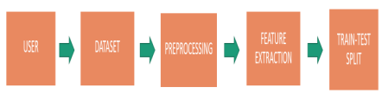

**Figure 2 – Level 1 - DFD**

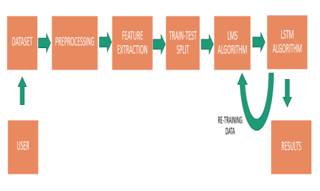

**Figure 3 – Level 3 – DFD**

**Proposed Stock Prediction Framework:**

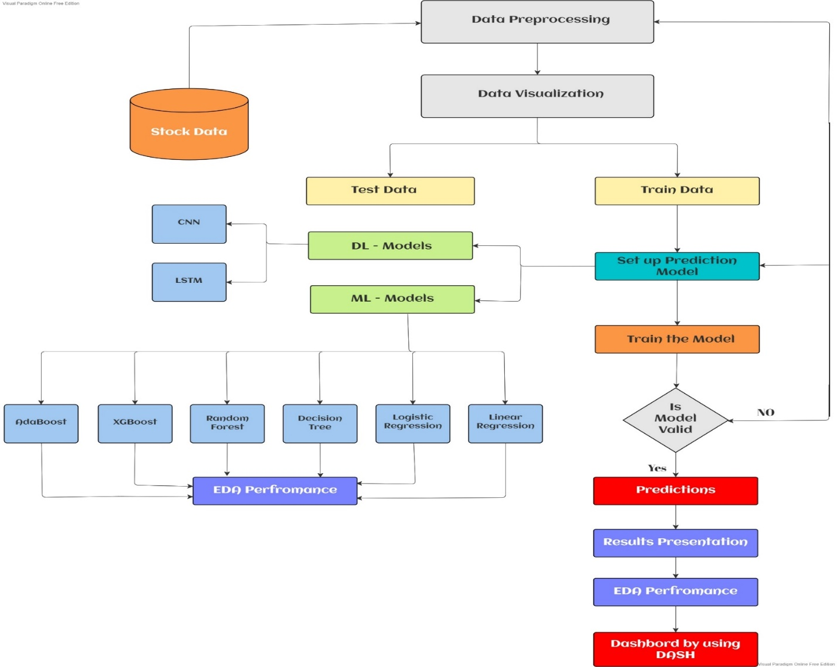

**Web Application Framework for Stock Trend Prediction by using Streamlit (Python WebApp)**

